**TestCase1- 2balls**

**Original Image:** **284 X 308.**The original image consists of 284 columns and 308 rows in the image.

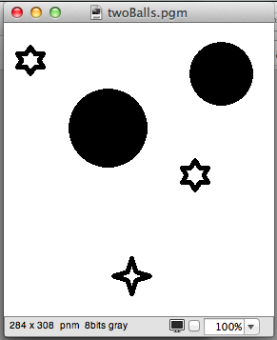

**Vertical Seam (68 seams): 216 X 308.**After removing 68 vertical seams from the original image, the image now consists of 216 columns and 308 rows. The image after processing is shown below:

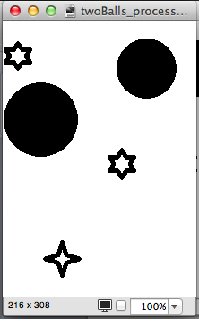

**Horizontal Seam (116 seams):** **284 X 192.**After removing 116 horizontal seams from the original image, the image now consists of 284 columns and 192 rows. The image after processing is shown below:

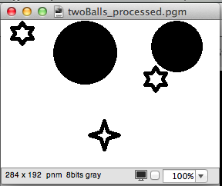

**Vertical and Horizontal Seam (68,211 seams):** **216 X 97.**

After removing 68 vertical and 211 horizontal seams from the original image, the image now consists of 216 columns and 97 rows. The image after processing is shown below:

